1. table() --> How many individual values are present



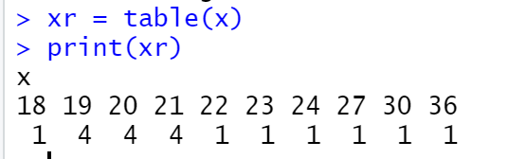

table() 🡪 will count the occurrences of individual items